Meta Description:
In this guide, you will learn about what is Snapchat Marketing, its key components, tools, placement types, and best practices to do it effectively in 2025. Read and Grow!
Interlink:
https://threeanglemarketing.com/what-is-social-media-marketing-how-does-it-work/
Snapchat Marketing
Images Requirements:
https://drive.google.com/drive/folders/1jgRELIBhiTWjH_jBfPQosBxxOg0fZop_

What is Snapchat Marketing and How to Do It in 2025?
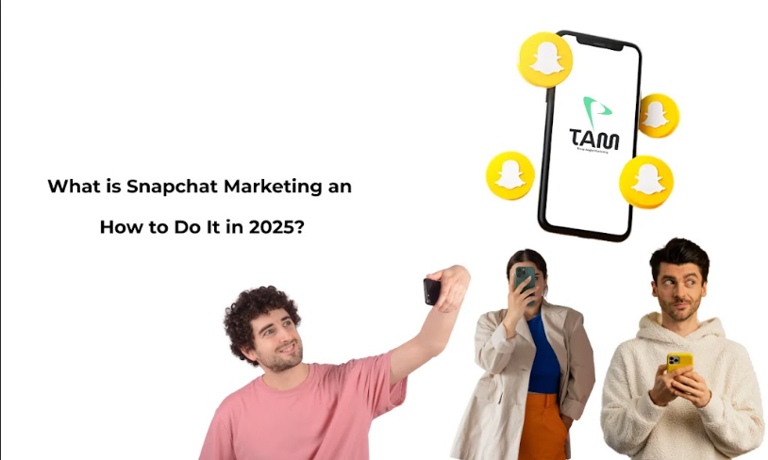

For businesses that seek to target generation Z, which is rather picky in terms of the media, it is high time to start with being one step ahead. Let us turn to Snapchat Marketing, which is the use of opportunities provided by the Snapchat application for branding purposes.
Snapchat marketing is definitely on a strong upward trajectory and it will continue to grow throughout the year 2025. In this blog, we will take a closer look at what Snapchat marketing is, what it includes, and specific specifications and placement types, importance, and tips for the present moment marketers should pay attention to.

What is Snapchat Marketing?
Snapchat marketing can be defined as the process of using the Snapchat platform for advertising and creating value for the brand in terms of sales, leads, customer engagement, or other similar objectives.
Snapchat is a social network that is attracting millions of people because of the opportunity to distribute messages that disappear after they have been opened? This feature helps the users to stay more natural, and it is effective for brands that would like to create more natural interactions or connections with viewers.
In the case of businesses, Snapchat marketing always come up with creative content that is relevant and in line with the platform's type. It is about having a fast message that can, disappear to the lower part of the screen or make the audience click on a Web page, fill in a mailing list, or buy something.

Key Components of Snapchat Marketing
To be familiar with Snapchat marketing, it is necessary to know several important characteristics. These form the foundation of any good Snapchat strategy that will give the intended results to your target audience and be beneficial to the business.
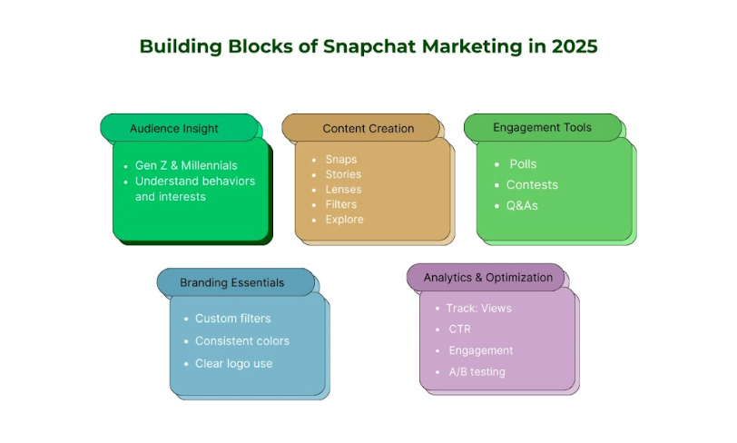

1. Audience
The first and foremost component of Snapchat's Marketing is its diverse audience. This platform is mainly famous among Gen Z and prefers general content, which is as close to real life as possible.
It is very important to comprehend their likes and behaviors, as well as behaviors interests. Before developing a strategic Snapchat marketing plan, determine your target audience what they are interested in, and also how they engage with this app. This will help you to orient your content generation and overall plan.

2. Content Creation
Content is king, and it still is a valid phrase for Snapchat, but in a different sense. Why? Because Snapchat posts and pictures are short-lived and therefore a lot of emphasis is placed on the content and speed. These are some content types that need to be classified:
- Snaps: These are photos or videos that can be shared and viewed for a limited amount of time only. It may also be recorded or live in the actual sense.
- Stories: A set designed to be viewed as one image at a time and can be presented for 24 hours, usually with a story or a sneak peek of your brand.
- Lenses and Filters: Fun and interactive activities or features that are added to snaps. Such activities also help increase brand awareness and generate user-created content.
- Explore: A content area that entitles content from the Publishers and Brands. What can be offered here is information of high quality or even entertainment, to a large number of people.
It is important to ensure that content is visually appealing and genuine, and must encompass the spirit of the brand with which you are associated.

3. Engagement
Engagement is an essential factor when it comes to Snapchat marketing. Promote audience engagement in the form of comments, likes, and direct messages as an effective form of engagement. Q&A sessions, giving out prizes, contests, and other activities can be used to increase the level of activity and a feeling of togetherness. To engage your audience, use features such as polls or questions within the Stories of Snapchat.

4. Branding
There is no excuse for having a bad branding presence on Snapchat because the essence of Snapchat is authenticity. In addition to compliance with the requirements of the text, ensure that brand colors, logos, and fonts are distinguishable in the content. A good approach that can be employed to ensure a strong consciousness of the brand for the followers of a particular brand is by employing custom filters and lenses.

5. Analytics and Optimization
Snapchat analytics is one of the great ways to track the effectiveness of Snapchat’s marketing campaigns. For better outcomes, you can track aspects like views, engagement rates, click-through rates, and other such statistics to see which perform well and which fail to perform. Put these observations into practice in staying up-to-date with the content and the strategy. With the trial of different content types, time of day to post, as well as different call to actions.

Snapchat Ad Specs and Placement Types
As with many other platforms, the advertising opportunities on Snapchat are dynamic. Having an insight into the current ad specifications and the types of placement existing in 2025 will assist you in coming up with successful campaigns that will target your audience.

Ad Specifications
This is a dynamic term that summarizes the guidelines and standards that are used while placing ads on the Snapchat platform. The considerations highlighted here are as follows:
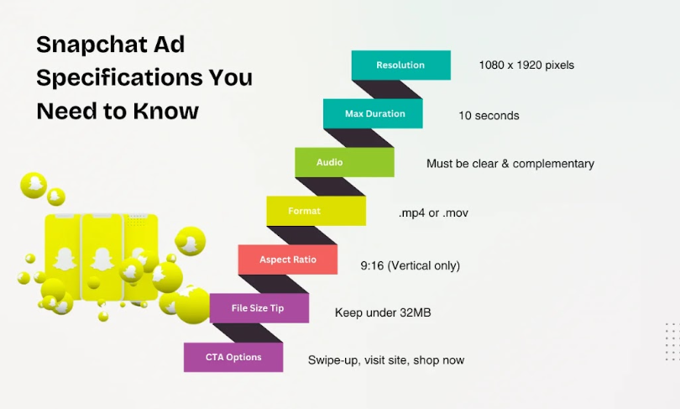
- Duration: Snap Ads are allowed to run up to 10 seconds. Although it’s quite short to deliver a message to get client attention.
- Audio: Make sure the audio complements the ad while at the same time does not overpower the visual aspect of the ad.
- Resolution: The nature of the content is often important, so you make sure that the content is highly resolved to avoid poor quality. You should create Snap Ads in the size of 1080 x 1920 pixels.
- Organization: Well-organized content make it easy to search for specific content which makes it easy to navigate the site or page at large. You should always consult with Snapchat about the FAQs in order to know about the preferred file size as per ad formats.

Ad Placement Types
Some of the ad placement types that are available for use on Snapchat are as follows:
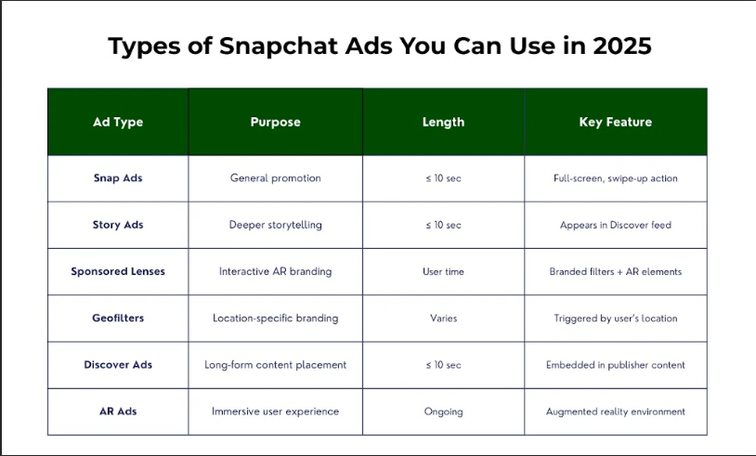

1. Snap Ads
Snap Ads can be displayed at the top or at the bottom of the Snap Map or as an ad in a Story list of a particular user. They include a pre-advert that lasts up to 3 seconds, a channel advert that lasts up to 10 seconds, and expands to a full-screen ad. It is most suitable for brand positioning of the company and product promotions.

2. Story Ads
Story Ads are the vertical mobile ads that appear within the user’s Stories feature. They can run up to 10 seconds and can contain features such as swipe-up, which leads the user to a website or a landing page. Story Ads are useful when it comes to brand promotion and stimulation of consumer action.

3. Sponsored Lenses
Branded Lenses are unique lenses designed by brands that are applied over Snaps. Such of lens provides an entertaining way of creating interaction with the users and getting additional exposure for brands. It can include filters, effects, and animation, as well as AR effects.

4. Sponsored Geofilters
Sponsored Geofilters are specific filters through which users can place their snaps and which are linked to a particular geographical area. They are suitable for advertising events, places, or companies because they enable them to give out the necessary information to the intended members or public. Geofilters ads can also be created with the company’s branding and personalized depending on the target audience in a certain area.

5. Discover Ads:
Discover Ads are presented in the Discover stream, where users scroll through the content shared by publishers and brands. These can be up to 10 seconds long and could be used when the aim is to educate or entertain a large group of people.

6. AR Ads:
Augmented Reality (AR) Ads provide an interaction environment that places a digital layer on top of the physical environment of the advertisement. AR is being immersive and subsequently making it perfect for interactive advertising. Any brand can make the experiences that the users interact with in the augmented environment obtainable in the actual environment, by creating memories that will be phenomenal.

Why Snapchat Marketing Is Important for Your Business?
Let’s discuss how Snapchat Marketing can prove beneficial for your business:

1. Reach a Younger Audience:
Snapchat is mainly popular among the youth, especially the Gen Z and millennials. It harbors over 300 daily active millennials, making it ideal for any firm that is targeting the youth market. Indeed, it is important to communicate with this segment of consumers because they are very influential and are part of the future generation of leaders and key decision makers. By engaging with the audience on Snapchat, you can target numerous consumers by have a high interest in brands and products.

2. Increase Brand Visibility:
The functions of Snapchat that include Stories, Lenses, and Discover can be a great platform for brands advertisement. By using them, a brand’s exposure is established and it finds its way to relevant niches in a very competitive online spectrum. That is why using Snapchat professionally, you can improve the recognition of a brand among the audience considerably.

3. Encourage Direct Engagement:
Snapchat fosters a more direct and personal form of engagement. The use of the platform’s functionalities is close to real-time, which enables brands to interact with the users through polls, quizzes, and other forms of active content. This kind of engagement can result in increased brand identification and therefore make the buyers return mostly if the brand makes them feel and get involved with a certain brand.

4. Leverage Influencer Partnerships:
There are many different influencers that are active on Snapchat and have a large following. In this way, interacting with such individuals will help in expanding your brand’s audience as well as increasing its reliability. The partnership with influencers on Snapchat may be effective because the spectators tend to trust influencers and their opinion.

5. Driving Real-Time Engagement:
To be specific, the content here disappears after 24 hours, which refers to its primary feature of Stories. This gives the user the feeling that it is important to read the latest updates as they are posted, prompting people to read content in real time. To the businesses, this opportunity produces timely and relevant content that will drive immediate engagement and conversion, such as discount promotions or flash sales.

How to Create a Snapchat Strategy in 2025?
The future of digital marketing for businesses aiming at achieving their goals in the next few years by the mid of the year 2025. Below is a checklist for creating a tailored Snapchat marketing strategy for the future.

1. Define Your Objectives
First of all, it is necessarily making precise goals and objectives that should be achieved in the framework of marketing communication. What are your objectives of using this channel, is it to create awareness of your brand, to sell something or to create awareness to one type of audience?
When you choose an objective, you can determine its effectiveness through which you can measure the success of your current strategies. When you are going to decide on the general strategy of your Snapchat activities, align it with what you want to achieve from your business.

2. Understand Your Audience
To be able to develop and design the right blog catering to its intended audience, several factors should be taken into consideration, particularly the audience that is to be targeted. You need to evaluate your audience’s demographics, the topics that engage them, and their activity on Snapchat. To identify the audiences, content, and the time of high engagement, leverage the analytics provided by the Snapchat application. Be relevant and catchy to your target audiences by adjusting the content to the frequency rate of the target audience’s usage and interest.

3. Develop Engaging Content
Content is king on Snapchat. The advice is to concentrate on developing the content that would fit the context of the social media and utilize this platform’s peculiarities. Some of the lenses that might be used include: interactive Stories, Lenses, and timely Snap Ads. To achieve this, ensure your content is as up-to-date as possible and comes out with a variety of new content regularly to meet its audience’s needs. Just as done before, Snapchat’s format is short, so make sure the messages are to the point but creative.

4. Leverage Snapchat’s Features
Below are some of the features available on Snapchat that can be of help in marketing; Stories is a feature which can be used for behind the scenes, a day in the life of, or a product launch. Develop Lenses to be integrated for the users to engage and post content. With this, organizations must look at Snapchat to discover how its AR features can help it create unique experiences for brands.

5. Collaborate with Influencers
This community management method involves searching and engaging with Snapchat influencers who are compatible with the brand and the audience. These include sponsored pictures, where a company pays the influencer to create a picture or anything related to the company and tag them on Snapchat. When choosing these affiliations, be sure to build them for the brand because the influencers’ followers are part of the brand group.

6. Integrate with Other Marketing Channels
It is most effective to connect Snapchat marketing to other platforms and use it as a complementary channel. Ensure that your Snapchat posts are shared on other social media accounts such as Facebook, Instagram, LinkedIn, Pinterest, YouTube, and Twitter to increase traffic.
Introduce your Snapchat and include direct links to it by using the email marketing strategy to make your followers reciprocate the same. An integrated marketing communication approach will help to employ a consistent message and is also a way of covering as many bases as possible.

7. Monitor and Optimize
To check the frequency and quality of the updates, use analytics tools and track the performance of your Snapchat. You should monitor parameters such as the reach, engagement, and the rate of conversions to evaluate the efficacy of the proposed strategy. Employ these suggestions to optimize your attempts and try out various forms and approaches to determine which one is more effective to reach your target populace.

8. Stay Ahead of Trends
Technology continues to advance in the digital space, and it is essential for you to adapt to the changing trends in the environment. Always be aware of feature updates and broader trends in the Snapchat platform as well as other social media, to maintain presented ideas fresh and relevant. Always be willing to take risks when it comes to technologies and other forms of media as they come into the marketplace.

9. Foster Community Engagement
Engaging with the Snapchat community can benefit your brand and contribute to additional sales and promotion by the clients. Implement branded hashtags and challenges in order to foster creativity amongst the users. Use Quizzes, Polls, Live Questions and Answers, and Stories as well. A good number of people connected in a community can easily attract followers of a brand and even become advocates promoting the brand.

10. Plan for Long-Term Growth
Lastly, there should be a long-term approach when it comes to practicing Snapchat marketing. For that purpose, you can set suitable milestones with timeframes of achieving certain Key Performance Indicators (KPI’s). Keep adjusting the strategy based on the performance results and users’ responses. It is easier said than done, but the long-term orientation guarantees constant growth and success, which would eventually lead to an adequate place in the digital space.

10 Pro Snapchat Marketing 2025 Tips
As Snapchat marketing is a relatively new form of advertising, below are ten things that a marketer needs to do to excel on the platform by 2025:
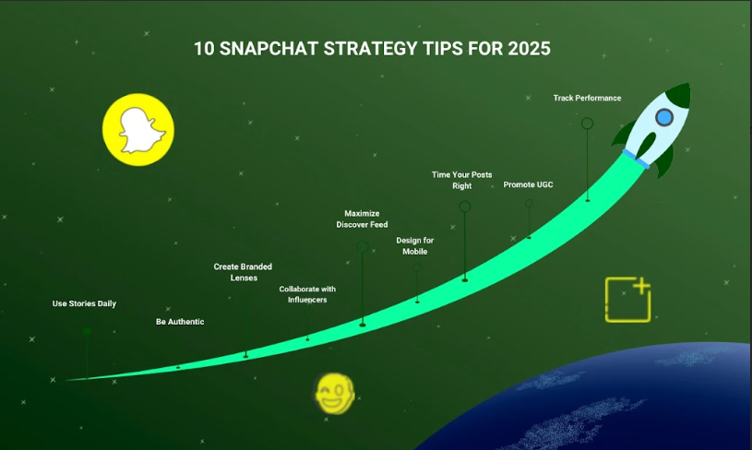

1. Leverage Snapchat Stories
Snapchat stories are something you use daily. Ensure that they are new, attractive, and engaging. To engage the users and get the information, make use of polls, questions, and quizzes.

2. Focus on Authenticity
Authenticity is key on Snapchat. Make your followers privy to exclusive information, events that occur in the moment, and life within and beyond the limelight that they otherwise will never be able to access.

3. Utilize AR Lenses
Augmented Reality lenses are becoming imperative due to the increasing importance in the digital world. Craft unique lenses that suit the image of your business. Such engagements can help increase the level of customer participation as well as brand recognition.

4. Collaborate with Influencers
Promote with Snapchat influencers who are brand-suitable. Many influencers can reach thousands, if not millions, of people. Therefore, they can help take your message to the targeted audience.

5. Engage with Discover
Snapchat came up with the Discover feature that allows for the production of lengthy content. Create content with information, entertainment, enlightenment, and entertaining materials that will always intrigue and appeal to the users to get more viewership for the brand.

6. Optimize for Mobile
Snapchat is a mobile-first platform. So, make sure your Snapchat content is properly mobile responsive and the images are clear, and the language is to the point.

7. Schedule Content Strategically
It’s important to stick to a particular plan and timetable while sharing content with the audience. You should use analytics to know the appropriate time that most people are active on Snapchat to get the highest point of interaction.

8. Encourage User-Generated Content
User-generated content establishes the synergy for a community base. Promote to your followers the idea of sharing their experiences with your brand via the Snapchat platform.

9. Track and Analyze Performance
You can use Snapchat analytics gadgets to gauge the company’s performance. It makes sense to pay attention to values such as reach, engagement, and conversion to improve the approach.

10. Stay Updated with Trends
Snapchat is constantly evolving. Be up to date with the trends to ensure your content is relevant to your customers.

Tools for Snapchat Marketing: Paid & Free
If you want to excel in Snapchat, then use the right tool. Here are some of the foremost paid and free software:
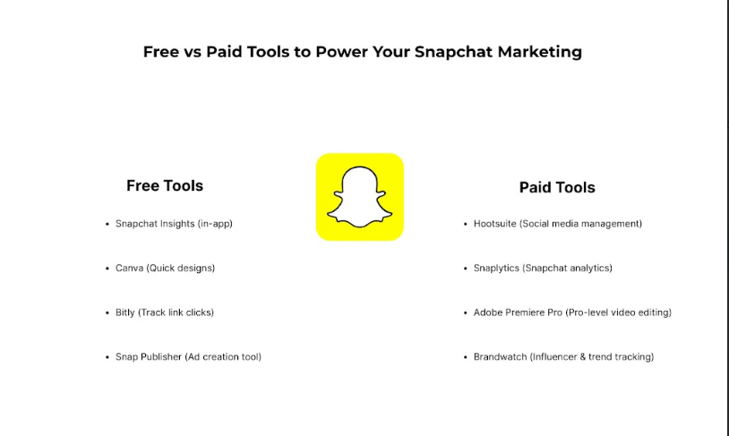

Free Tools

1. Snapchat Analytics
Evaluate performance metrics using analytics settings that are already integrated in the Snapchat platform to know the behavior of your targeted audience.

2. Canva
Canva allows creating visually appealing content due to the provided unique design tools. Before applying an SVG template, adjust it to fit the organization’s overall corporate identity.

3. Hootsuite
Snapchat is one of the social networks that Hootsuite lets you schedule and manage. Review and interact with your audience concerning its performance on different social media platforms.

4. Buffer
It is similar to Hootsuite as Buffer enables users to schedule content and monitor the performance of the posts on social media platforms.

5. Trello
It will help you to organize your snap campaigns using Trello. This tool can be used as the starting point for forming a strategy for the implementation process checking.

Paid Tools

1. Planoly
Some of the features in Planoly include scheduling and planning of content. Preview the content before it goes to the audience and check the appearances to ensure that they will be coherent.

2. Sprout Social
Sprout Social specializes in handling and scheduling your Snapchat, and the platform has more information regarding Snapchat compared to other social media platforms.

3. Later
Later is a social media management tool that comes with the ability to do the planning and schedule content. It has features such as a calendar for visualizing content creation to ensure that task is made easy.

4. Crowdfire
It is one of the tools that assists you in always keeping track of your Snapchat audience and even growing it for you. It provides an influencer marketing platform, content discovery, and analytics.

5. Sensor Tower
To monitor the outcome of your Snaps and the general performance of your campaigns on Snapchat, you can use Sensor Tower. Through this tool, you can learn more about the number of impressions, clicks, and conversions.

Ending Thoughts:
The future of Snapchat marketing strategy in 2025 will require creativity, authenticity, and expiry appropriate tools. If you want your Snapchat marketing to succeed, you need to be proactive, enthusiastic about innovations and trends, and patient.
If done right, Snapchat marketing could easily help enhance brand loyalty, increase engagement, and achieve the set business goals within the highly dynamic and fluid digital world.
At Three Angle Marketing, we will help you to understand Snapchat marketing and how to achieve the goals of your business in 2025 and beyond. Let’s connect today to convert your Snapchat Marketing efforts into ROI delivering activities.

